

Vidyavardhini’s College of Engineering & Technology

Department of Artificial Intelligence and Data Science (AI&DS)

|  |  |
| --- | --- |
| **Name:** | Vinith Shetty |
| **Roll No:** | 55 |
| **Class/Sem:** | SE/IV |
| **Experiment No.:** | 4 |
| **Title:** | Program to display character in uppercase and lowercase. |
| **Date of Performance:** | 13/02/2024 |
| **Date of Submission:** | 20/02/2024 |
| **Marks:** |  |
| **Sign of Faculty:** |  |

**Aim:** Assembly Language Program to display character A to z in both uppercase and lowercase

**Theory:**

DOS provide various interrupt services that are used by the system programmer. The most commonly used interrupt is INT 21H. It invokes inbuilt DOS functions which can be used to perform various tasks. The most common tasks are reading a user input character from the screen, displaying result on the exiding program etc.

In this program, we display the characters A to Z on the DOS prompt. DOS interrupt function 02 displays the contents of DL (ASCII code) on the screen. By loading the ASCII code of 'A' in the DL register, loading AH register with 02h and calling INT 21h it is possible to display character from A to Z on the screen.

INT 21h/AH = 2 - write character to standard output.

Entry: DL = character to write, after execution AL = DL.

**Example :-**

mov ah , 2

mov dl , 'a'

int 21h



**Flowchart:**

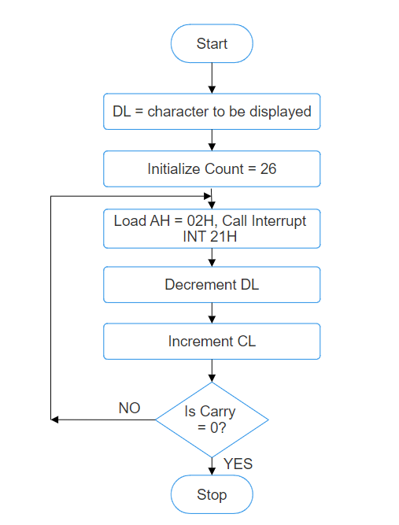

**Algorithm:**

1. Start.

2. Initialize DL with 'A'.

3. Load CL with count = 26.

4. Load AH = 02H and call INT 21H.

5. Increment DL, to next character.

6. Decrement the count.

7. Repeat steps 4,5,6 till CL is not zero.

8. To end the program use DOS interrupt:

1) Load AH = 41H.

2) Call INT 21 H.

9. Stop.

**Code:**

**org 100h**

**mov cx, 1Ah**

**mov dl,'a'**

**L1:**

**mov ah, 02h**

**int 21h**

**inc dl**

**dec cx**

**jnz L1**

**mov dl, 0ah**

**int 21h**

**mov dl, 0dh**

**int 21h**

**mov cx, 26**

**mov dl,'A'**

**L2:**

**mov ah, 02h**

**int 21h**

**inc dl**

**dec cx**

**jnz L2**

**ret**

**output:**

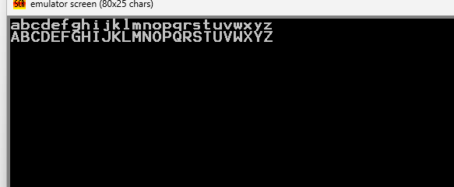

**Conclusion:**

The assembly language program displays the lowercase and uppercase letters of the English alphabet sequentially on the console. It utilizes loops, ASCII character manipulation, and console output functions (`int 21h`) to achieve this task efficiently.

1. Explain INT 21H.



* `INT 21h` is a software interrupt in x86 assembly language, mainly used in DOS systems. It offers a range of services such as file operations, input/output, process control, and more. By setting specific values in CPU registers, programmers can request services like character input/output or file manipulation. While its usage has declined with the decline of DOS, `INT 21h` remains important for historical purposes and compatibility with legacy software.

1. Explain working of increment and decrement instructions.

* Increment and decrement instructions are used to increase or decrease the value of a register or memory location by one, respectively, in assembly language programming.
* - **Increment**: The `INC` instruction increases the value of the operand by one. For example, `INC AX` increases the value in the AX register by one.
* - **Decrement**: The `DEC` instruction decreases the value of the operand by one. For instance, `DEC BX` decreases the value in the BX register by one.
* These instructions are commonly used in loops, counters, and arithmetic operations, offering a compact and efficient way to manipulate numerical values.